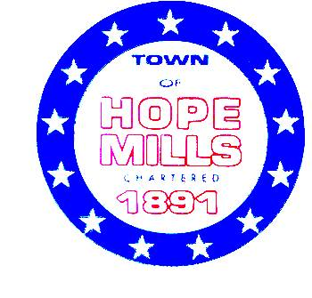

TOWN OF HOPE MILLS
COMMITTEES VACANCY NOTICE

THE TOWN OF HOPE MILLS ENCOURAGES YOUR PARTICIPATION IN GOVERNMENTAL DECISIONS. DESCRIPTIONS OF THE VARIOUS COMMITTEES WITH VACANCIES ARE LISTED BELOW. COMMITTEE MEMBERSHIPS ARE RESERVED FOR TOWN RESIDENTS UNLESS OTHERWISE STATED. INDIVIDUALS MAY SERVE ON UP TO TWO COMMITTEES.

APPEARANCE COMMISSION
Established by town ordinance, the Appearance Commission is a 7-member Commission that seeks to enhance and improve the visual quality and aesthetic characteristics of the town.
Vacancies: 5
When they meet: the 4th Tuesday of each month at 6:30 pm.

CULTURAL ARTS ADVISORY COMMITTEE
The Cultural Arts Committee provides representation for the citizens of Hope Mills in partnership with the Town Parks and Recreational Department and the Town Board of Commissioners in promoting, encouraging, and increasing support for the town’s artistic and cultural assets as well as working to integrate arts and culture into community life.
Vacancies: 1
When they meet: 2nd Thursday of each month at 6:30p.m.

HOMELESSNESS ADVISORY COMMITTEE
The Hope Mills Homelessness Advisory Committee is a 7 member committee charged with engaging nonprofit homeless providers, victim service providers, faith-based organizations, governments, businesses, advocates, public housing agencies, school districts, social service providers, mental health agencies, hospitals, universities, affordable housing developers, law enforcement, military agencies, organizations that serve homeless and formerly homeless veterans, and homeless and formerly homeless to bring awareness and curate solutions to Homelessness in Hope Mills.
Vacancies: 2
When they meet: 2nd Tuesday of each month at 6:00p.m.

PRIME MOVERS COMMITTEE
This 7-member Committee was established to advise the Hope Mills Board of Commissioners (BOC) on issues relevant to the attraction, retention and engagement of Hope Mills residents between the ages of eighteen to thirty-nine. The committee is dedicated to improving communications with the BOC regarding the quality of life for young adults by providing recommendations related to programs and actions that affect this age group.
Vacancies: 4
When they meet: 1st Tuesday of each month at 6:00 p.m.

VETERANS AFFAIRS COMMITTEE
The 7-member committee is composed of town residents who are armed services veterans. The members of this committee advise the town on affairs related to our active and retired military citizens.
Vacancies:2
When they meet: the 4th Thursday of each month at 6:00 p.m.

It is important to note that this application may be considered a public record and as such, portions may be subject to release under North Carolina General Statute Chapter 132, Public Records. If you or anyone else you may know is interested in serving on a committee, please complete the application. Applicants must reside inside the Hope Mills Town limits or within the Municipal Influence Area; at the discretion of the Hope Mills Board of Commissioners and in compliance with any State or Federal regulations.

Not sure if volunteering is for you: see existing Board and Committee member share what they enjoy about volunteering. https://youtu.be/OKsSt5VSIPc

An application can be found on the Town’s Website Form Center • Board Application Form (townofhopemills.com) or you may pick one up at Town Hall 5770 Rockfish Road, Hope Mills, NC.

